# What to Do When Gmail Is Not Syncing?

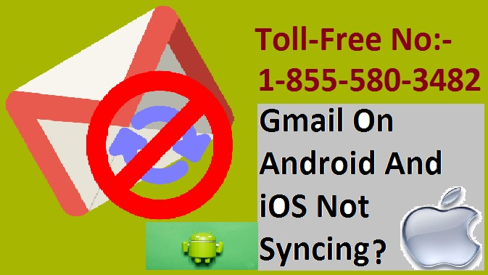

**Introduction**

Gmail is, additionally, a known online email administration that's given by Google and it's started on 1 April 2004. Gmail is incredibly straightforward to utilize and provides many areas. Email is an integral part of everyone's life today. Arguably, we depend on our email over we have a tendency to do the mailman to deliver envelope and packages to our door. We have a tendency to keep in a bit with family and friends mistreatment email. We even receive electronic copies of our bills. We conjointly get our magazine subscriptions, newsletters, coupons, necessary reminders, requests for job interviews, and concerning the rest you'll be able to consider delivered to the USA electronically via email.

It's in addition mixed with Google's fully totally altogether all completely different administrations like Google Buzz, Google speaks, and others and it is available in 105 languages. They provide varied administrations like send/get mail, drivers update, recovery secret key and many of more. Gmail had a capability limit provider of one hardware unit for each shopper and presently, Gmail administration accompanies fifteen gigabytes of capability.

If you’re having Gmail issues, significantly once syncing the app along with your Gmail account, you will end up unable to perform a number of the foremost basic email functions. Issues that may occur include:

* Inability to send an email
* Inability to open or browse new emails as they arrive
* Not receiving any new emails
* The app runs unbelievably slowly

**When Android Gmail Is Not Syncing**

1. Try a manual synchronizes. To see if it's potential to still synchronize the app and your account, open the Gmail app and swipe from the top of the screen to the bottom. If that refreshes your inbox, you simply performed a manual synchronize.

2.Enable automatic sync:

* Open the Gmail app.
* Tap the three-bar menu icon.
* Scroll down, tap Settings, and so tap your account name.
* Scroll down to the info usage heading and tap adjust Gmail to alter automatic synchronization.

3. Make sure you are online. You wish to be online to adjust your Gmail app, which needs either Wi-Fi or a cellular knowledge association. Make sure that Airplane Mode isn’t enabled because it will knock you offline and stop Gmail from syncing together with your mobile devices.

4. Check your password. Go to mail.google.com and attempt to log in. If you get a password error, which will be why the app is not syncing properly. Change your password on each device and syncing may match properly once more.

5. Update the app and downloading the most recent version of the Gmail app will generally be all it takes to try and do away with Gmail correct issues.

6. Clear Gmail app data:

* Open your device's Settings.
* Tap Apps and Notifications or, on older versions of Android, tap Apps.
* Locate the Gmail app within the list of applications and tap it.

7. Restart your device. Generally, a restart is all it takes to get your smartphone or tablet operating properly. Most devices will be restarted by pressing and holding the ability button then tapping restart from the menu.

**When iOS Gmail Is Not Syncing**

1. Go to the Gmail homepage in a browser on your pc (or on your iOS mobile net browser) and log in.

2. Tap the Settings cog at the top of the screen and choose Settings within the drop-down menu.

3. Click Forwarding and POP/IMAP.

4. Now scroll down to the IMAP access section and choose to enable IMAP if it is disabled.

5. Select save changes.

Hopefully, these solutions will help you to Gmail sync in android as well as iOS. In case you are dealing with any technical issue so you can contact 1-855-580-3482 [Gmail technical support number](https://www.emailhelpdesk.us/support-for-gmail.html).